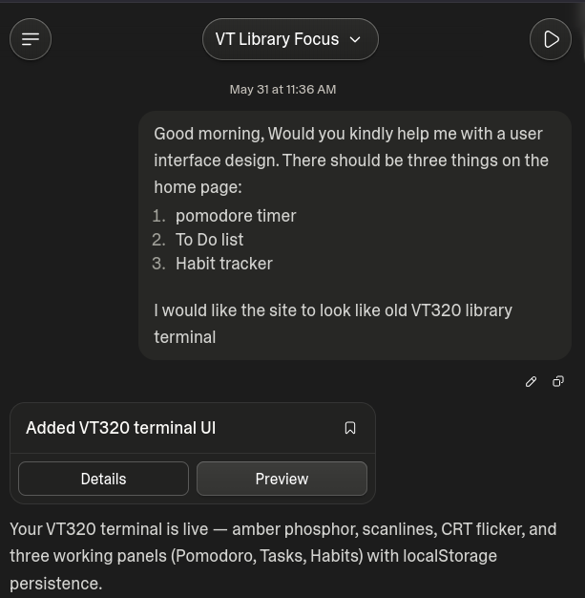

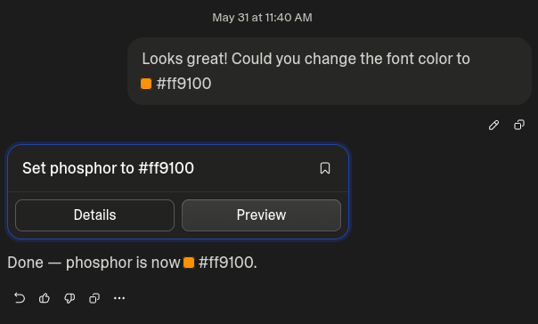

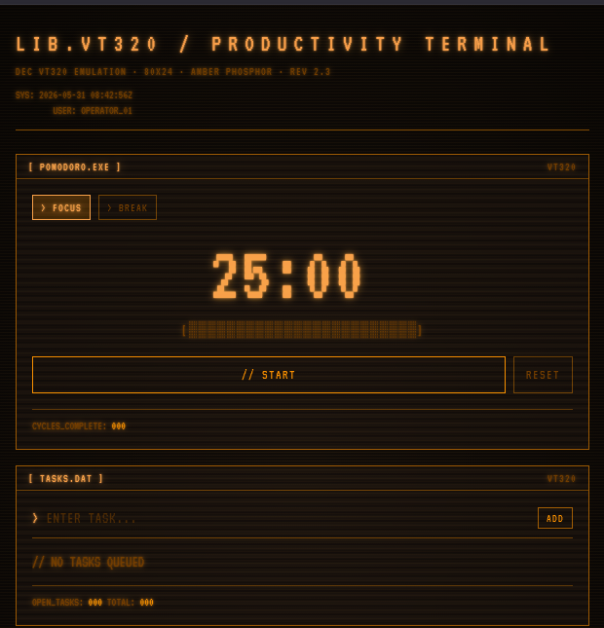

[ Habit Tracker VT320 Design ]

Q: The Tool: Which tool did you choose and why?
A: I chose to use lovable, we used it in our webdev course with our project & it seemed pretty good.
Q: The Experience: How did designing through "conversation" feel compared to the traditional design process in Figma?
A: I already knew that it will be easier & I do like the fact we had same execution with the user interface. First mockup I did on photoshop by hand, then figma & this, so this took the least time forsure.
Pros and Cons:
Q: Did the AI save time on routine tasks?
A: Sure it saved time, but personally I would not use it that much. Maybe in the future but as timebeing I want to learn myself how to do things & avoid using AI when ever possible. (So basicly I only use it when assignment forces to use it.)
Q: Did the AI understand your creative vision, or did you feel like you were "fighting" the algorithm?
A: It understood me perfectly. Im surprised it nailed the VT320 style (Old terminal made by DEC used commonly in libraries back in the day)
Q: Was the output high enough quality to serve as a real basis for a prototype?
A: Output was way better then mine, site actually had the CRT flickering & glow, which I did want for my site but...yeah didint do.
Q: What challenges or limitations did you face?
A: Really didint face any challenges or limitations, it nailed the look and functionality straight up.
Q: The Future: How do you believe these tools will change the role of a UI/UX designer over the next year?
A: Well I think its time to accept the truth. AI is a super fast tool that will be integrated in many fields.
Programming & design is already heavily affected by it.
I would recommend checking out indie web called neocities.org.
People creating “old” style websites, following the ideas from Tim Bernes-Lee how he wanted the web to be.

